**Population:** Population can be view as whole universe which contains all the data of the world.

**Sample:**  It is the subset of the Population which is picked from population to perform some statistical operation on it, while trying to figuring out some results on population.

Let’s take ex given in below image in which population is people in whole world, and sample is 1000 people picked from population for performing operation, like here we are finding the average/mean height of human.

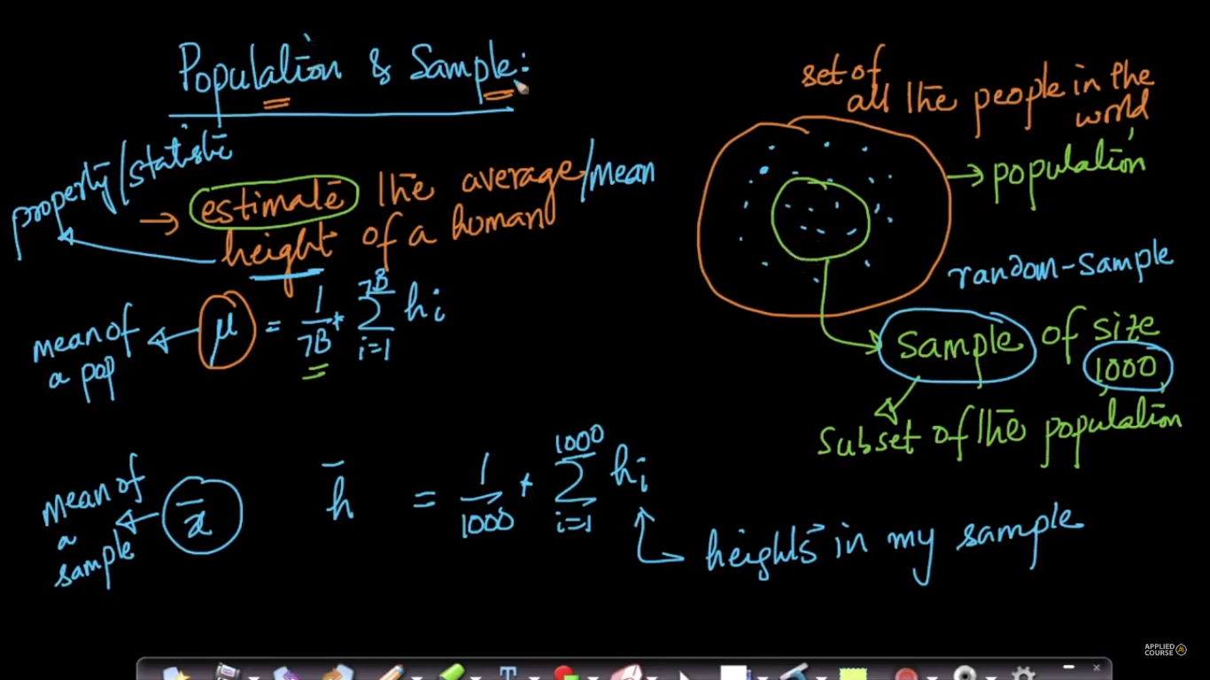

As size of sample increases the mean o f sample becomes much closer to population mean.

A